Shaun Hingson

Professor Adams

Com 437 Mobile Application Development

October 23, 2020

Assignment 1

* **Project Description**

RUN CLUB APP

Application that tracks running progress and allows user the ability to set goals, record pace and train for upcoming events. This application will log events and progress utilizing a note pad and a calendar.

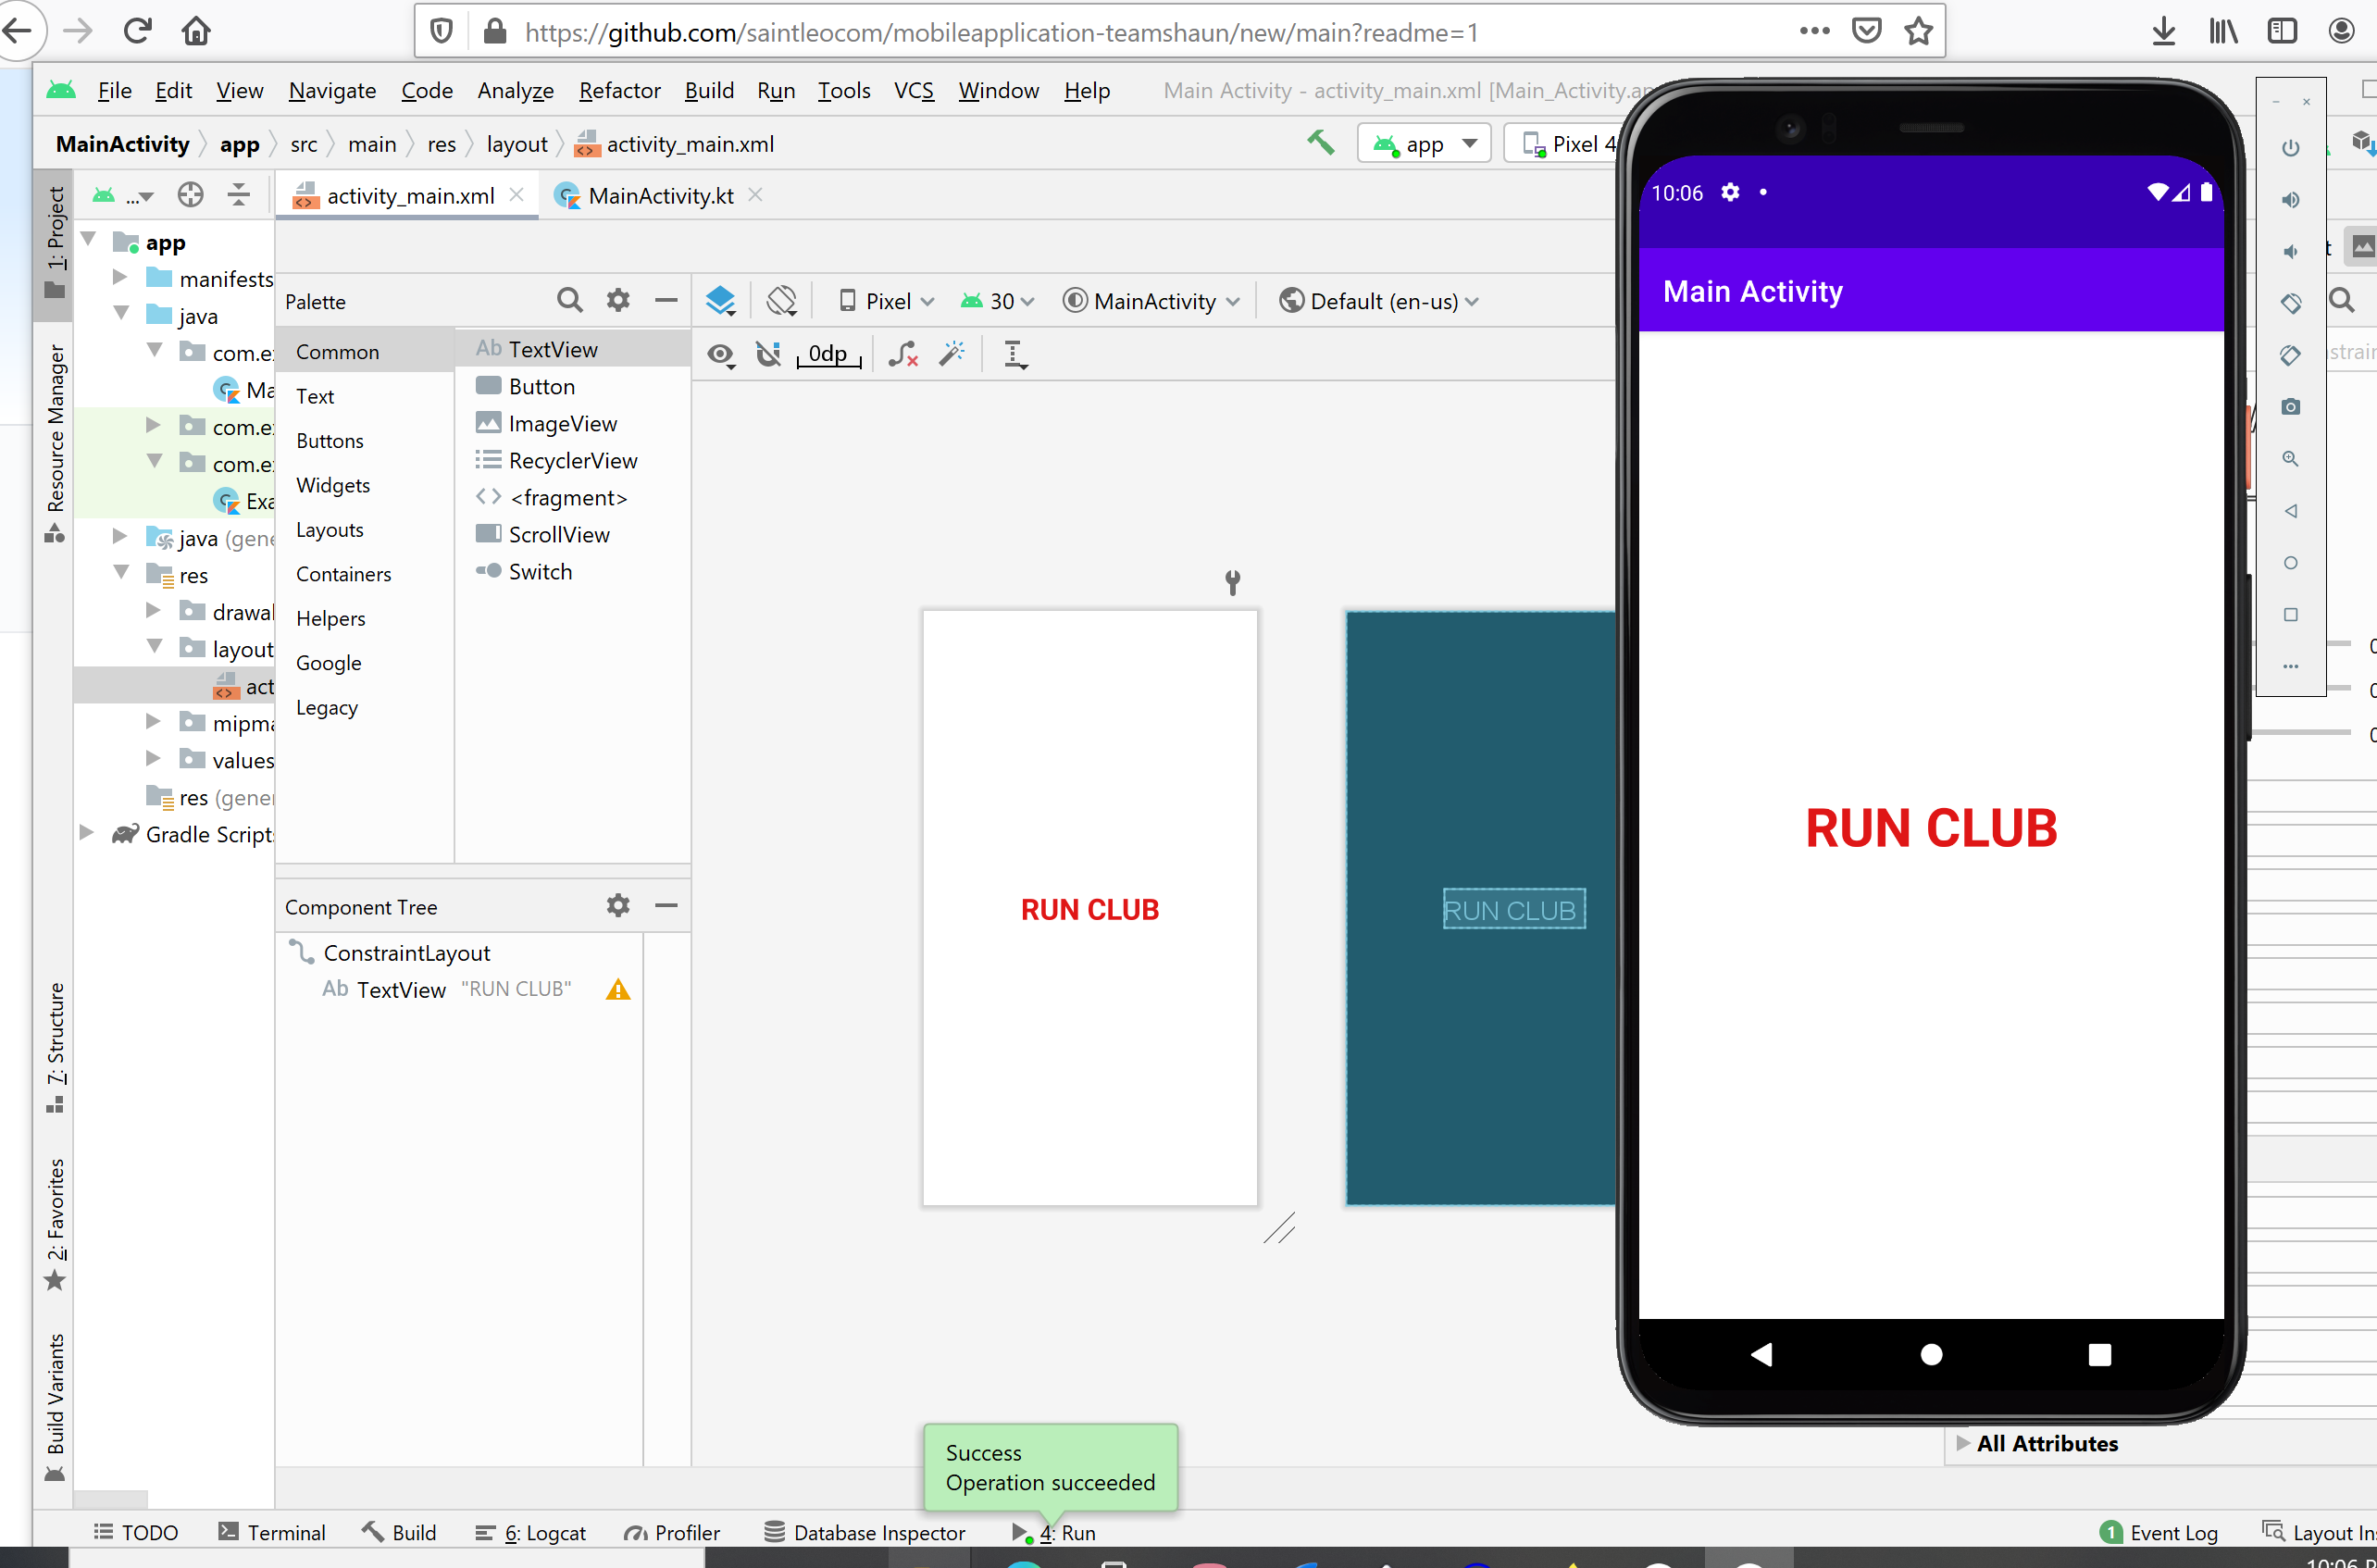

* **Problem Addressing**

Millions of people run to stay healthy, relieve stress or just for fun. This application will help people train and prepare for an upcoming event. They can view the notepad and set goals as well as track progress for future events.

* **Platform**

The platform will be Android based and up to date with the latest version Android 11.

* **Front/Back end Support**

This will maintained by myself.

* **Functionality**
* The app will be designed for simplicity with quick and easy data entry. The information will be stored and viewable through a notepad as well as a calendar.
* **Design**

The design will be clean with buttons and a lay out that utilizes the calendar.

<https://github.com/shaunhingson/RUN-CLUB-APP.wiki.git>

